**JOIN US FOR OUR**

**PRIMARY ELECTION NIGHT WATCH**

**- - - - - - - - - - - - - - - - - - - - - - - - - - - - - - - - - - - - - - - - - - - -**

**RE-ELECT STATE REPRESENTATIVE**

**JERRY O’CONNOR**

**Republican for theNew 60th District:**

***(City of Fond du Lac, Village of North FDL,***

***& Towns of: Empire, Fond Du Lac & Friendship)***

**“STANDING STRONG FOR**

**COMMONSENSE CONSERVATIVE VALUES”**

**WHEN: tUESDAY August 13TH / 7:00 – 10:00P.M.**

**WHERE: KORNELIS FAMILY CENTER/ 605 FOND DU LAC AVE/ FDL**

***PIZZA AND DRINKS PROVIDED***

***Please RSVP at:*** [*Joc@jerryoconnor4wi-assembly.com*](mailto:Joc@jerryoconnor4wi-assembly.com)



**WARNING: The extreme liberals began with a strategy to capture the legislature by gerrymandering new district lines in an effort to capture the State Legislature with more liberals. Republicans will lose seats!**

Right now, they are bringing in millions of out-of-state donations to elect liberals and finish their plan to convert the legislature into a rubber stamp for Tony Evers and his WOKE agenda. We cannot let that happen.

**This includes my District:**

Can I humbly count on you to donate to my campaign to insure that Wisconsin returns a conservative legislature to Madison?

***MAKE CHECKS PAYABLE TO: COMMITTEE TO ELECT JERRY O’CONNOR***

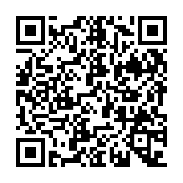**MAIL TO P.O.BOX 651 • FOND DU LAC, WI 54936**



**OR SCAN HERE >>>**

**TO DONATE ON-LINE**

*Paid for by the Committee to Elect Jerry O’Connor*